**Freedom of Press and Censorship of Media in Bangladesh**

**Amrin Khondokar**

In 2022, Bangladesh was ranked 162 out of 180 in the Press Freedom Index of Reporters without Borders, a global media watchdog known as Reporters Sans Frontières (RSF). RSF has described the freedom of the Bangladesh media as “Bangladeshi journalists face violence from police, political activists, and militants”. They also mentioned that “a certain editorial independence” was maintained by The Daily Star and Prothom Alo. (S. D. Report, “Bangladesh 162nd out of 180 Countries in Press Freedom Index, Scores Lowest in South Asia”) The World Press Index considers media independence and self censorship. It also bases on the opinions of experts worldwide and data on abuse and violence against journalists. Bangladesh was 152nd in the same index in 2021(S. D. Report, “Bangladesh 152nd out of 180 Countries in World Press Freedom Index”). Over the years, fake news, ignored/censored information, and the spread of propaganda have become common scenarios in Bangladesh. In this paper, I will discuss the censorship of media in Bangladesh, examine the possible reasons for it, and assess the overall freedom of the press.

Freedom of the press, according to the Bangladesh constitution, encompasses the censorship and endorsement of public opinions, fundamental rights, freedom of expression, and human rights in print, broadcast, and online media. Bangladesh has a hybrid legal system for journalism, and according to its constitution, independent journalists, media bias, and misinformation are illegal. However, under these laws, the Bangladesh government also creates media bias and fake news for its own positive image.

In recent years, Bangladesh has started to focus more on online media. The reason is simple: a larger number of internet users are the youth. Not only that, but the quarantine regulations of the COVID-19 pandemic have just started to lift slowly. During the entire quarantine period, people got more dependent on the internet to receive news and connect with people. This is why, at the start of the pandemic, the Bangladesh government began controlling the spread of online news and started to strictly surveil the citizens of the country and their social media presence. The most common ones were: 1. Blocking/Hiding, 2. Filtering. 3. Spreading fake news

Blocking or hiding certain words was the easiest way for the government to control the spreading of any news. Specific words or IP addresses of certain individuals were easily blocked by the government, both nationally and internationally. The words of people would vanish and become unsearchable on all social media, especially Facebook, the most used social media by the people of Bangladesh. The second one is filtering. This is to filter specific information from the whole event to tweak it to their liking, which can make a victim look like the aggressor or can make one group look better than the other. Third is the spreading of blatant fake news. Even if the news can be proved false, large news sites would still spread this news. And the general audience would not verify the said news. This was the best way to spread propaganda.

Blocking and filtering were extensively implemented during the 2018 student-led movement, named the Road Safety Movement. Bangladesh has blocked access to social media by restricting speed and blocking certain words or removing/filtering evidence from social media. The Road Safety movement started because of two teenagers who were crushed by a bus while it was racing with others on the road. (BBC News)

Students all across the country mourned their departure on social media. However, their feelings slowly turned into rage due to the lack of law regulations for road safety and the overall unsafe road constructions all over the country. They started to demonstrate on the street, starting one of the most significant movements in the country. They began protesting against the lackluster and improper imposition of the traffic rules. However, within a few days, the police began to show violence against the students, using tear gas and rubber bullets on the youth. The demonstrators decided to post evidence of violence on social media. Various videos and images proving the government instructed violence were posted everywhere by the student, and it spread like wildfire across various sites like Facebook, Instagram, WhatsApp, and Twitter. Popular Reddit posts and trending hashtags helped the incident be shared all across the globe.(“Bangladesh Student Protests Trend on Reddit, Twitter”). To damage control, only after a few hours, the Ministry of IT shut off the internet for an extended period across the country. People of Bangladesh were slowly losing connection with each other and the outside world. At first, on Twitter, any hashtags in the Bangla language were taken down at the instruction of the then government. Later, students decided to post using #WeWantJustice hashtag, which was trending for a few hours at first, but was later taken down without any proper explanations. (“Bangladesh Student Protests Trend on Reddit, Twitter”)

Another incident occurred in March 2021; Muslim activists protested about letting the Prime Minister of a country they opposed enter. To shut off this protest, Facebook and Messenger were restricted, and the Internet speed was slowed down. Although all government representatives denied that the clash was a reason for such restrictions on the internet, many suspected otherwise.

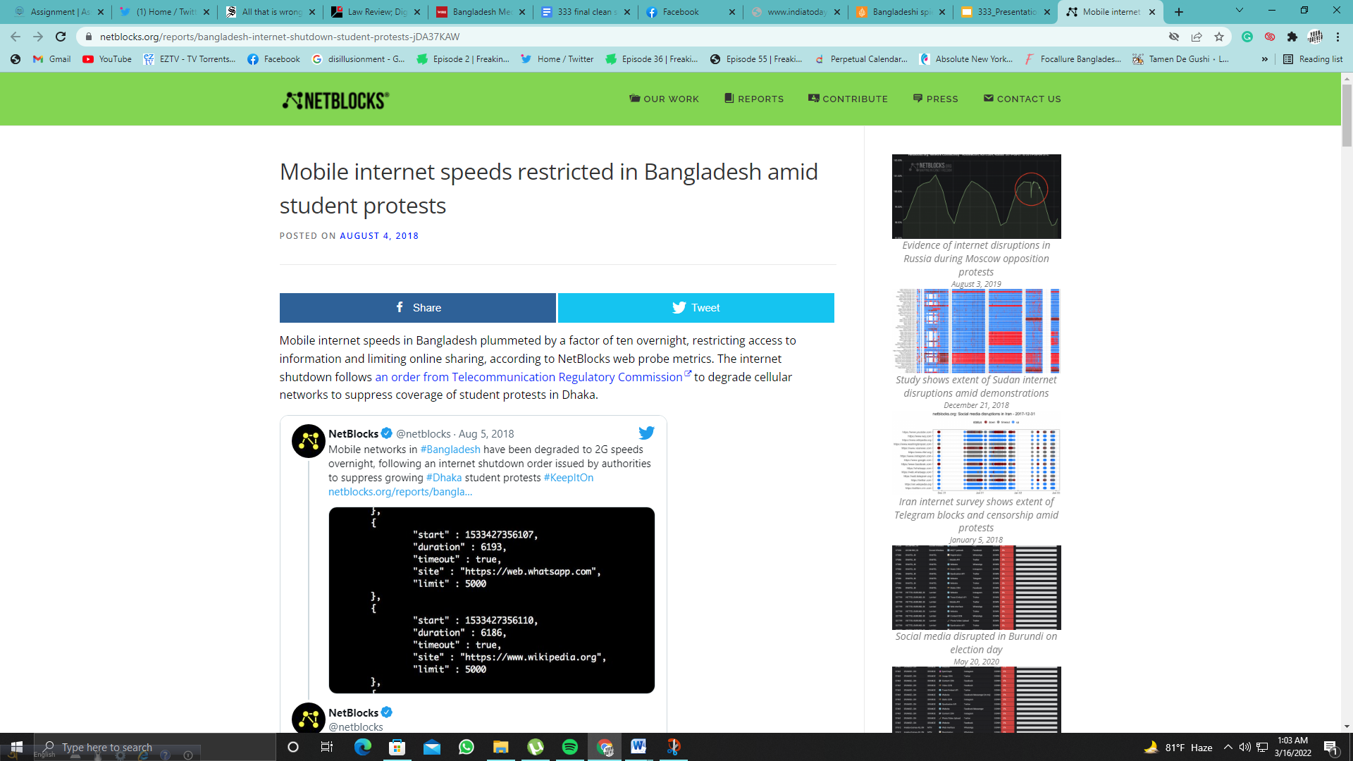

(Source: <https://netblocks.org/reports/bangladesh-internet-shutdown-student-protests-jDA37KAW>)

After the end of the Road Safety Movement, the Bangladesh Government began to have more control over social media. Now they could finally filter out posts, as they got permission to monitor from META. They began filtering any posts harmful to the Bangladeshi Government’s image, initiating their many-year-long reign over social media censorship. Critical pieces of art or news could be labelled as rumors or damaging and could easily be traced and people behind the posts could be threatened to delete the published piece. This played in favour of the Awami League government in the General Elections of 2019. They could portray themselves as perfect, helping and justifying their landslide win once again. (Correspondent) The authorities further got an upper hand when Facebook complied to become a registered taxpayer of the country and agree to share intel with the Government in case of any uprising against them or propaganda. (S. Islam)

Spreading of fake news became quite prevalent post Road Safety movement and during the start of COVID-19 pandemic. Multiple fact checking websites have proved misinformations that were spread through large news sources of the country. Before the 2019 elections, fake news credited the Awami League leader, Sheikh Hasina as the second best Prime Minister of the world. This was called out by The Wire, an Indian news portal, who explained how minimum the government was doing to limit these fake news. (Shishir, “Bangladesh Media Doing Little to Counter Fake News Being Spread by Government”)

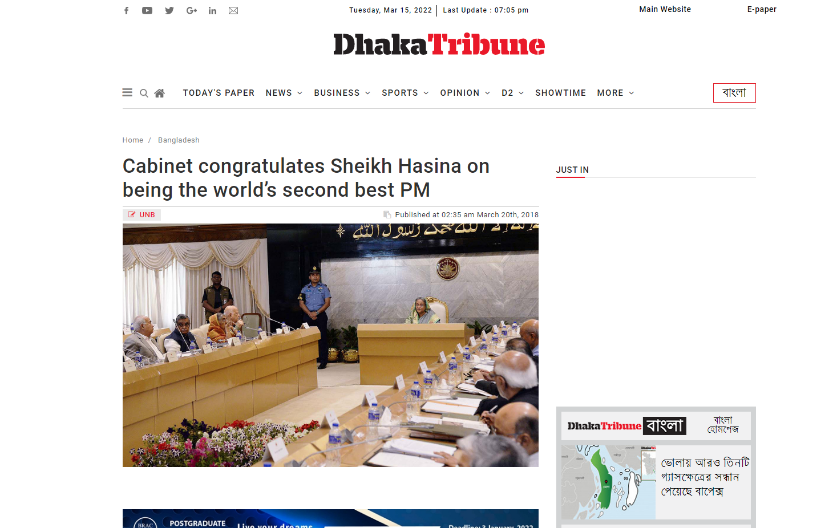

(“Cabinet Congratulates Sheikh Hasina on Being the World’s Second Best PM”)

After the start of COVID-19 pandemic, fake news regarding COVID and Bangladesh’s response to it was spread all over the country. One of the fact checking websites known as Boom Bangladesh decided to expose the famous news sites spreading fake news. In 2020 and 2021, multiple well known news sources have published fake news. Though the number of fake news reduced from the highest being 10 in the year 2020 to highest being 3 in 2021. 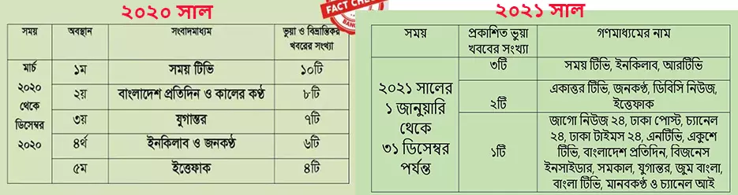

(Source:h[ttps://www.boombd.com/fact-file/top-stories-in-2021-boom-bangladesh-fake-news-fact-check-misinformation-disinformation-mainstream-media-politics-bangladesh-16371](https://www.boombd.com/fact-file/top-stories-in-2021-boom-bangladesh-fake-news-fact-check-misinformation-disinformation-mainstream-media-politics-bangladesh-16371))

While not all fake news pieces were about the Bangladesh Government, many were. Furthemore this large amount of fake news was a result of heavy censorship mandated by the government.

Another advantage that came for the Bangladeshi government was their newly enacted Act, the Digital Security Act of 2018. This helped them criminalize reporters, artists, writer and more. Though at surface it was said that this act is to diffuse defamation against the country and the Liberation War of 1971, the sections under them can easily be seen to be against any free thinking of the people. Now, under a certain act, the government could prosecute pretty much anyone. And their permission to surveil multiplied their advantage against the people. There are a few sections that are to be mentioned as they were significant to target media personalities.

Firstly, Section 25, which criminalizes the publishers who would spread information with the intention of damaging the image or reputation of the country. For such offense, one would be getting 3 years of jail and 3 lac taka fine, and this punishment might increase in case of several similar offenses. However, whether the news is harmful could not be verified by a third party in the court. Second, section 21, suggests punishing any individual or group who are trying to spread any propaganda or false information against the 1971 Liberation War. This included destroying the spirit of the war or demeaning the father of the nation, Bangabandhu Sheikh Mujibur Rahman. Spreading such stories might result in 10 year imprisonment and 1 crore taka fine. (Taken from the original Digital Security Act article)

Journalists and activists in Bangladesh took it to the streets to protest for the freedom of speech and expression, which this act will violate. Though the government initially promised to not use these laws against journalists and artists, they used the same act to prosecute many activists.

This act was heavily used during the COVID-19 pandemic and any critical piece that came along with it. This helped the government to hide the corruption or their miscalculated response to the pandemic. For example: Rozina Islam, an investigative journalist of Prothom Alo, was arrested after she discovered the corruption going under the Government’s COVID Response. She reported on medical equipment being left at Dhaka Airport for several months, corruption in the recruitment of doctors and in the procurement of the health ministry. (Al Jazeera)

Along with her many other people who were critical were also detained during 2020 and 2021. Most of these people were arrested without a warrant using the Digital Security Act. And many of these personalities were victims of assault and abuse during their jail time. Multiple victims also passed away during this time. Cartoonist Kishore Ahmed and writer Mushtaq Ahmed were convicted because of their critical response to the corruption of Bangladesh. Their responses were dubbed as anti-government ideologies published on their social media. It was mentioned that their ideas damaged the reputation of the country. Writer Mushtaq Ahmed passed away in February 2021 in custody; his bail was denied 6 times before that. (“Cartoonist Kishore to Stand Trial in Digital Security Case for ‘Anti-State Propaganda’”). After Kishore was released, he had to be treated for burst eardrum and many other injuries he sustained while being jailed. Authorities later denied conducting any type of violence against him.

This was not the first time media personalities were convicted by this act. Photojournalist Shahidul Alam was arrested under Section 57, because of his interview with Al Jazeera about quota reform and Road Safety Movement and how the Awami League Government lost credibility over time. (Ahmed)

Out of reach journalists were also threatened by intelligence agencies, through their family members. In 2020, an interagency memo of the UN by the World Health Organization states that Bangladesh was poorly prepared to tackle this ongoing coronavirus pandemic. This memo was published by Netra News, along with a warning that if the Bangladesh government does not take any proper action now, more than 2 million citizens can die from the epidemic. This caused the intelligence agency of Bangladesh to threaten the mother of the Editor in Chief of Netra News. The mother, Naznin Khalid was visited by three men in Sylhet, a city away from the capital. Then men proceeded to threaten her and warned her to stop his son, who is in asylum in Sweden, to stop publishing articles that might Turkish the reputation of Bangladesh. (The Diplomat)

The government also has a history of hiding military violences towards minorities. Ad revenue was blocked by threatening sponsors of news sites The Daily Star and Prothom Alo, two of the most prominent news sites of the country. Both of these sites have published the news of 5 indigenous people being killed by armed Army officers in Chittagong Hill Tracts. The news sites later reported that they have lost almost 25 to 35% of their yearly ad revenue due to their lack of sponsors in online and offline sites. (Bergman)

As a democratic state, Bangladesh has to allow the Freedom of Expression for the citizens of the country, including the media personalities. However, democracy and its laws did not apply to the media and press of Bangladesh. “But Democracy is government by public opinion, and it is mainly the printing press that makes possible the development and expression of opinion.” (Long 225–26) The media influences people to create their own speeches and opinions. Published media can often convey criticism or praise of the authority, which can, in general, create public opinion in favour or opposition of the authority. This is why vital figures of authority, like the Bangladesh Government, find it crucial to control the media. Their year-long control has impacted the media industry drastically. Journalists and publishers try to avoid the wrath of the Government, and find ways to control the media. For years, journalists have blatantly avoided news of Government workers corruption, violence and more. Sometimes they hid information from stories that were known to general people. Despite being called out, they would not change the news. However, this behaviour undermines the rights of people who are living under a democratic regime. The people have the complete right to correct news and timely information. After so many years of witnessing the media scenario, the low rank in the press freedom index was not surprising to most people of the country.

References:

Ahmed, Qumr “Why Did Bangladesh Arrest Shahidul Alam?” Sheikh Hasina | Al Jazeera, 9 Aug. 2018, <https://www.aljazeera.com/opinions/2018/8/9/why-did-bangladesh-arrest-shahidul-alam>

Al Jazeera, “Rozina Islam: Bangladesh Arrests Journalist for COVID Reporting.” Media News | Al Jazeera, 20 May 2021,   
<https://www.aljazeera.com/news/2021/5/18/rozina-islam-bangladesh-arrests-journalist-for-covid-reporting>

“Bangladesh: Crackdown on Social Media” Human Rights Watch, 28 Oct. 2020,

<https://www.hrw.org/news/2018/10/19/bangladesh-crackdown-social-media>

“Bangladesh Student Protests Trend on Reddit, Twitter.” Dhaka Tribune, 5 Aug. 2018, <https://www.dhakatribune.com/feature/152301/bangladesh-student-protests-trend-on-reddit>

BBC News, “Bangladesh Protests: How a Traffic Accident Stopped a City of 18 Million” BBC News, 6 Aug. 2018, <https://www.bbc.com/news/world-asia-45080129>

Bergman, David “Bangladeshi Spied Accused of Blocking Media Adverts” Media | Al Jazeera, 7 Oct. 2015, <https://www.aljazeera.com/features/2015/10/7/bangladeshi-spies-accused-of-blocking-media-adverts>

“Cabinet Congratulates Sheikh Hasina on being the World’s Second Best PM” Dhaka Tribune, 19 Mar. 2018, <https://www.dhakatribune.com/bangladesh/141114/cabinet-congratulates-sheikh-hasina-on-being-the>

“Cartoonist Kishore to Stand Trial in Digital Security Case for ‘Anti-State Propaganda’” [Bdnews24.com](http://bdnews24.com), 27 Feb. 2022,

[bdnews24.com/bangladesh/2022/02/27/cartoonist-kishore-to-stand-trial-in-digital-security-case-for-anti-state-propaganda](http://bdnews24.com/bangladesh/2022/02/27/cartoonist-kishore-to-stand-trial-in-digital-security-case-for-anti-state-propaganda) (Article is now deleted)

Correspondent, Staff. “Govt to Introduce ‘Content Filtering’ to Check Social Media Rumors” Prothomalo, 6 Aug. 2018

<https://en.prothomalo.com/bangladesh/Govt-to-introduce-%E2%80%98content-filtering%E2%80%99-to-check>

Deutsche Welle([www.dw.com](http://www.dw.com)) “Bangladesh: Fake News on Facebook Fuels Violence” [DW.COM](http://dw.com), 1 Nov. 2019, <https://www.dw.com/en/bangladesh-fake-news-on-facebook-fuels-communal-violence/a-51083787>

“Facebook, Messenger Likely to be Restored in Bangladesh by Sunday” Dhaka Tribune, 27 Mar. 2021, <https://www.dhakatribune.com/bangladesh/242319/facebook-messenger-likely-to-be-restored-in>

Hammadi, Saad “Bangladesh’s ‘Fake News’ Law is Used to Stifle Dissent” The Diplomat, 19 Aug. 2021, https://thediplomat.com/2021/08/bangladeshs-fake-news-law-is-used-to-stifle-dissent/

Islam, Muhammad Zahidul. “Govt Can Now Filter Online Contents” The Daily Star, 20 Sept. 2019, <https://www.thedailystar.net/frontpage/bangladesh-govt-can-now-monitor-block-filter-online-facebook-contents-1802497>

Islam, Syful. “Bangladesh Tightens Grip on Facebook, Twitter and Other Platforms.” Nikkei Asia, 9 Sept. 2021, [asia.nikkei.com/Politics/Bangladesh-tightens-grip-on-Facebook-Twitter-and-other-platforms](http://asia.nikkei.com/Politics/Bangladesh-tightens-grip-on-Facebook-Twitter-and-other-platforms)

Long, Jos. R. “The Freedom of the Press.” Virginia Law Review, vol. 5, no. 4, 1918, p. 225. Crossref, <https://doi.org/10.2307/1063583>.

Report, Star Digital. “Bangladesh 152nd out of 180 Countries in World Press Freedom Index.” The Daily Star, 20 Apr. 2021,

[www.thedailystar.net/world/news/world-press-freedom-index-finds-journalism-blocked-over-100-countries-2080641](http://www.thedailystar.net/world/news/world-press-freedom-index-finds-journalism-blocked-over-100-countries-2080641).

Report, Star Digital. “Bangladesh 162nd out of 180 Countries in Press Freedom Index, Scores Lowest in South Asia.” The Daily Star, 4 May 2022, [www.thedailystar.net/news/bangladesh/rights/news/bangladesh-162nd-out-180-countries-press-freedom-index-scores-lowest-south-asia-3016866](http://www.thedailystar.net/news/bangladesh/rights/news/bangladesh-162nd-out-180-countries-press-freedom-index-scores-lowest-south-asia-3016866).

Shishir, Qadaruddin. “Bangladesh Media Doing Little to Counter Fake News Being Spread by GovernmentÂ.” The Wire, 3 Apr. 2018, [thewire.in/media/bangladesh-media-doing-little-to-counter-fake-news-being-spread-by-government](http://thewire.in/media/bangladesh-media-doing-little-to-counter-fake-news-being-spread-by-government).

Shishir, Qadaruddin. “Bangladeshi Media’s Troubling Tango with Fake News.” The Daily Star, 18 Mar. 2022, [www.thedailystar.net/views/opinion/news/bangladeshi-medias-troubling-tango-fake-news-2985186](http://www.thedailystar.net/views/opinion/news/bangladeshi-medias-troubling-tango-fake-news-2985186).

The Diplomat. “Bangladesh Is Suppressing Free Speech During the COVID-19 Pandemic.” The Diplomat, 2 May 2020, [thediplomat.com/2020/04/bangladesh-is-suppressing-free-speech-during-the-covid-19-pandemic](http://thediplomat.com/2020/04/bangladesh-is-suppressing-free-speech-during-the-covid-19-pandemic).

Additional Information was taken from the article on the Digital Security Act 2018

<https://www.cirt.gov.bd/wp-content/uploads/2020/02/Digital-Security-Act-2020.pdf>

Fact Checker picture from <https://www.boombd.com/fact-file/top-stories-in-2021-boom-bangladesh-fake-news-fact-check-misinformation-disinformation-mainstream-media-politics-bangladesh-16371>